The Business Rules
University:

Each university has a unique identifier (UniversityID).
The name of the university is stored in the UniversityName attribute.
College:

Each college is uniquely identified by CollageID.
Colleges are associated with a university through the UniversityID foreign key.
The CollageName attribute stores the name of the college.
Lecturer:

Lecturers are uniquely identified by LecturerID.
The specialization of a lecturer is stored in the Specialize attribute.
The LecturerName attribute holds the name of the lecturer.
Lecturers are associated with a university through the UniversityID foreign key.
Department:

Each department is identified by a unique DepartmentID.
Departments are associated with a college through the CollageID foreign key.
The DepartmentName attribute stores the name of the department.
Course:

Courses are uniquely identified by CourseID.
Courses are associated with a department through the DepartmentID foreign key.
CourseName represents the name of the course.
The number of credit hours for a course is stored in the CreditsHours attribute.
Student:

Students are uniquely identified by StudentID.
Students are associated with a department through the DepartmentID foreign key.
StudentName represents the name of the student.
The Hours attribute represents the number of hours a student is taking.
Student_Course:

Represents the many-to-many relationship between students and courses.
The Degree attribute stores the student's grade in a course (percentage).
CourseID and StudentID are foreign keys referencing the Course and Student tables, respectively.
Course_Department:

Represents the schedule of courses within a department.
CourseDay represents the day on which the course takes place.
StartTime and EndTime represent the time range for the course.
CourseID and LecturerID are foreign keys referencing the Course and Lecturer tables, respectively.

The ERD

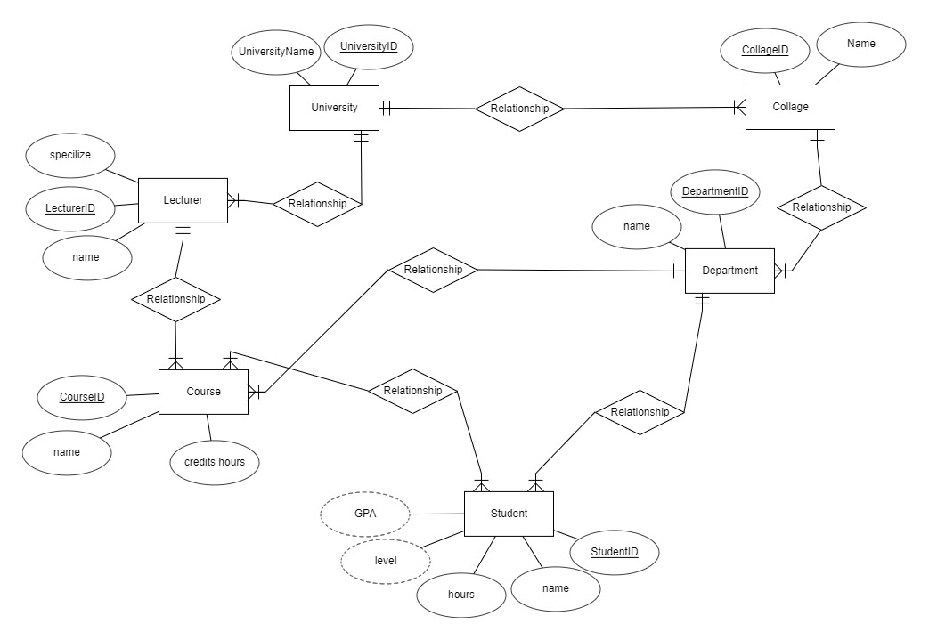

Logical Database Schema

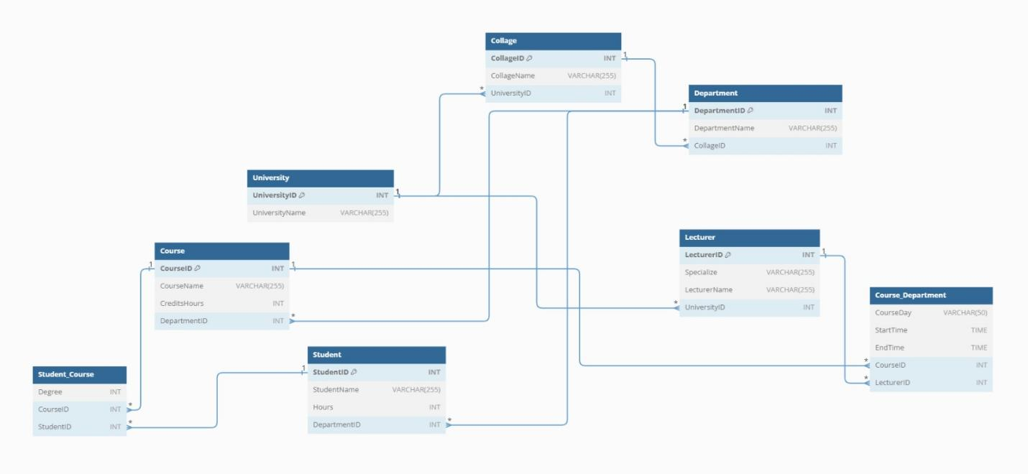

Normalization Steps
- We have split the course table into two tables one for course id and name and department id as a foreign key and the other is to make a new date for a course with the start time and end time and lecturer id
And we have not add derived attributes and we did the things as above

This is the MYSQL Code

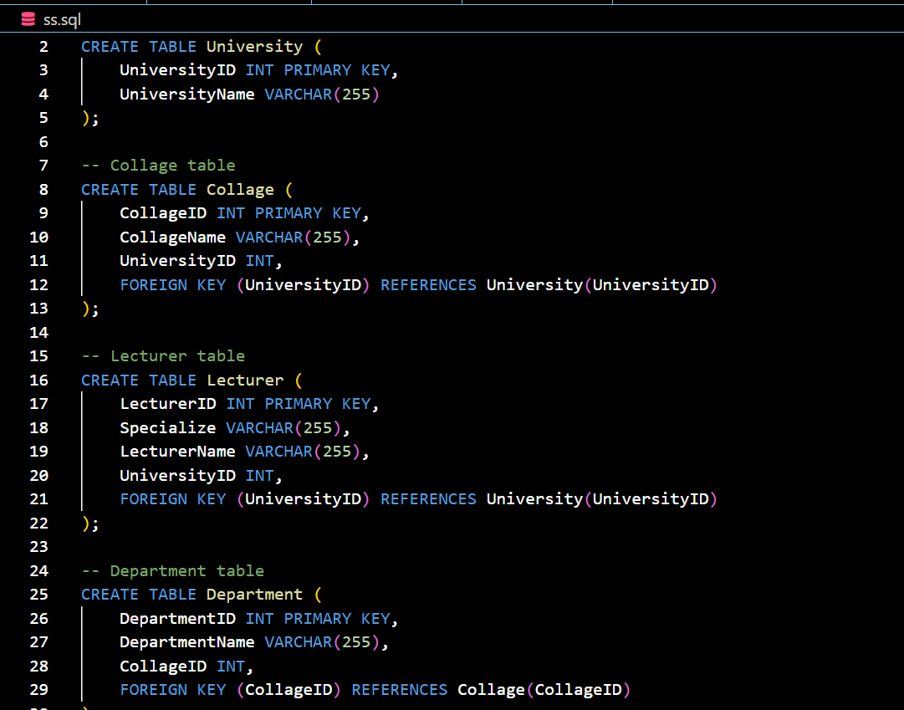
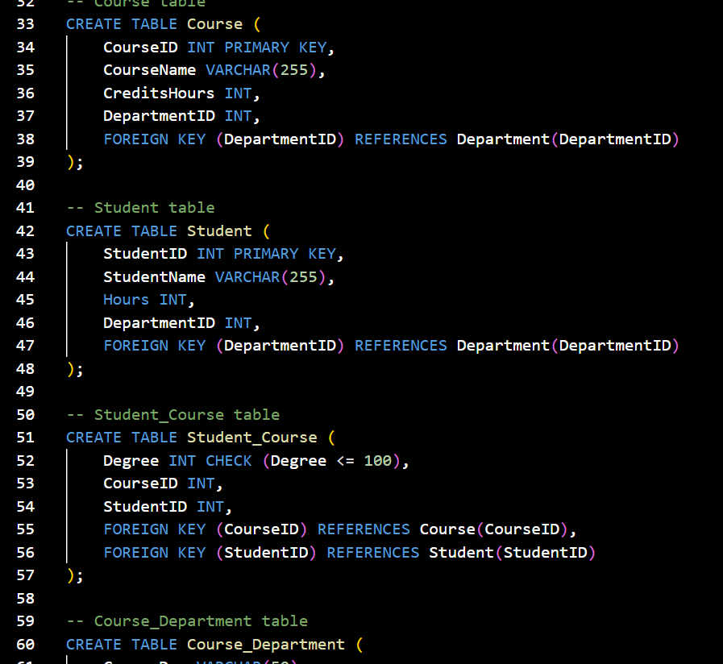

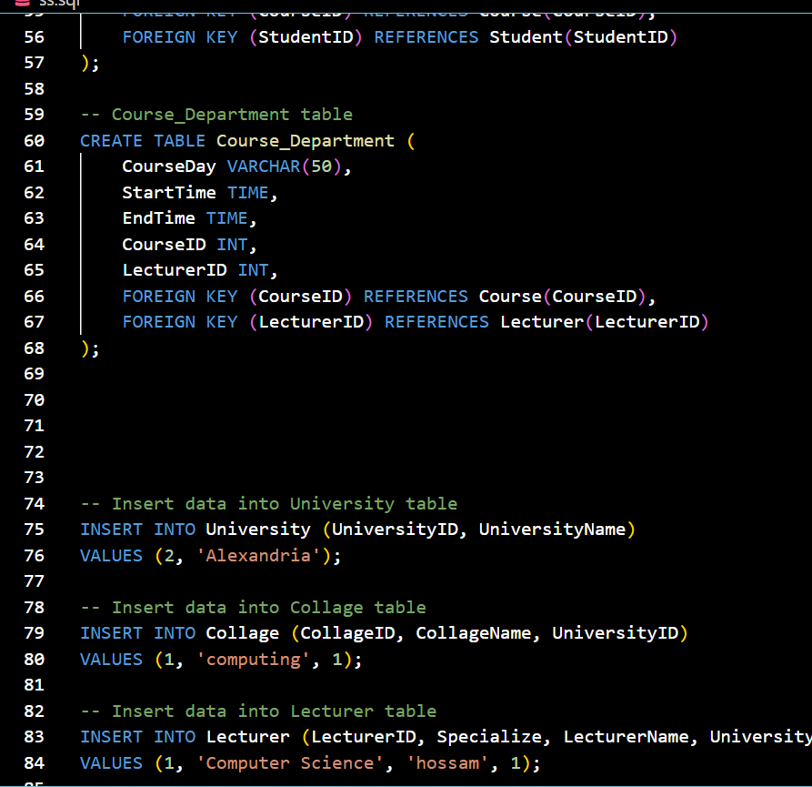

This Is The Code Script
-- University table
CREATE TABLE University (
UniversityID INT PRIMARY KEY,
UniversityName VARCHAR(255)
);

-- Collage table
CREATE TABLE Collage (
CollageID INT PRIMARY KEY,
CollageName VARCHAR(255),
UniversityID INT,
FOREIGN KEY (UniversityID) REFERENCES University(UniversityID)
);

-- Lecturer table
CREATE TABLE Lecturer (
LecturerID INT PRIMARY KEY,
Specialize VARCHAR(255),
LecturerName VARCHAR(255),
UniversityID INT,
FOREIGN KEY (UniversityID) REFERENCES University(UniversityID)
);

-- Department table
CREATE TABLE Department (
DepartmentID INT PRIMARY KEY,
DepartmentName VARCHAR(255),
CollageID INT,
FOREIGN KEY (CollageID) REFERENCES Collage(CollageID)
);

-- Course table
CREATE TABLE Course (
CourseID INT PRIMARY KEY,
CourseName VARCHAR(255),
CreditsHours INT,
DepartmentID INT,
FOREIGN KEY (DepartmentID) REFERENCES Department(DepartmentID)
);

-- Student table
CREATE TABLE Student (
StudentID INT PRIMARY KEY,
StudentName VARCHAR(255),
Hours INT,
DepartmentID INT,
FOREIGN KEY (DepartmentID) REFERENCES Department(DepartmentID)
);

-- Student_Course table
CREATE TABLE Student_Course (
Degree INT CHECK (Degree <= 100),
CourseID INT,
StudentID INT,
FOREIGN KEY (CourseID) REFERENCES Course(CourseID),
FOREIGN KEY (StudentID) REFERENCES Student(StudentID)
);

-- Course_Department table
CREATE TABLE Course_Department (
CourseDay VARCHAR(50),
StartTime TIME,
EndTime TIME,
CourseID INT,
LecturerID INT,
FOREIGN KEY (CourseID) REFERENCES Course(CourseID),
FOREIGN KEY (LecturerID) REFERENCES Lecturer(LecturerID)
);

Here is some sample Data

University Table

SELECT * FROM University;
UniversityID | UniversityName
2 | Alexandria

Collage Table
SELECT * FROM Collage;
CollageID | CollageName | UniversityID
1 | Computing | 2

Lecturer Table
SELECT * FROM Lecturer;
LecturerID | Specialize | LecturerName | UniversityID
1 | Computer Science | hossam | 1

Department Table
SELECT * FROM Department;
DepartmentID | DepartmentName | CollageID
1 | Computer Science Department | 1

Course Table
SELECT * FROM Course;
CourseID | CourseName | CreditsHours | DepartmentID
1 | Database Management | 3 | 1

Student Table
SELECT * FROM Student;
StudentID | StudentName | Hours | DepartmentID
1 | Moaz | 12 | 1

Student_Course Table

SELECT * FROM Student_Course;
Degree | CourseID | StudentID
90 | 1 | 1

Course_Department Table
SELECT * FROM Course_Department;
CourseDay | StartTime | EndTime | CourseID | LecturerID
Monday | 09:00 | 12:00 | 1 | 1

-- Insert data into University table
INSERT INTO University (UniversityID, UniversityName)
VALUES (2, 'Alexandria');

-- Insert data into Collage table
INSERT INTO Collage (CollageID, CollageName, UniversityID)
VALUES (1, 'computing', 1);

-- Insert data into Lecturer table
INSERT INTO Lecturer (LecturerID, Specialize, LecturerName, UniversityID)
VALUES (1, 'Computer Science', 'hossam', 1);

-- Insert data into Department table
INSERT INTO Department (DepartmentID, DepartmentName, CollageID)
VALUES (1, 'Computer Science Department', 1);

-- Insert data into Course table
INSERT INTO Course (CourseID, CourseName, CreditsHours, DepartmentID)
VALUES (1, 'Database Management', 3, 1);

-- Insert data into Student table
INSERT INTO Student (StudentID, StudentName, Hours, DepartmentID)
VALUES (1, 'Moaz', 12, 1);

-- Insert data into Student_Course table
INSERT INTO Student_Course (Degree, CourseID, StudentID)
VALUES (90, 1, 1);

-- Insert data into Course_Department table
INSERT INTO Course_Department (CourseDay, StartTime, EndTime, CourseID, LecturerID)
VALUES ('Monday', '09:00', '12:00', 1, 1);

SELECT * FROM University;

SELECT * FROM Collage;

SELECT * FROM Lecturer;

SELECT * FROM Department;

SELECT * FROM Course;

SELECT * FROM Student;

SELECT * FROM Student_Course;

SELECT * FROM Course_Department;

University Management System Interface Report
Page 1: Students
1.1 Add Student
This section allows the addition of new students to the system. Two fields are present:
Student's Name: Allows new students to input their names in any language.
Department ID: Enables students to input their Department IDs.
1.2 Delete Student
This section facilitates the deletion of a student from the database using the Student ID, which is a digital number with a minimum of 8 digits.
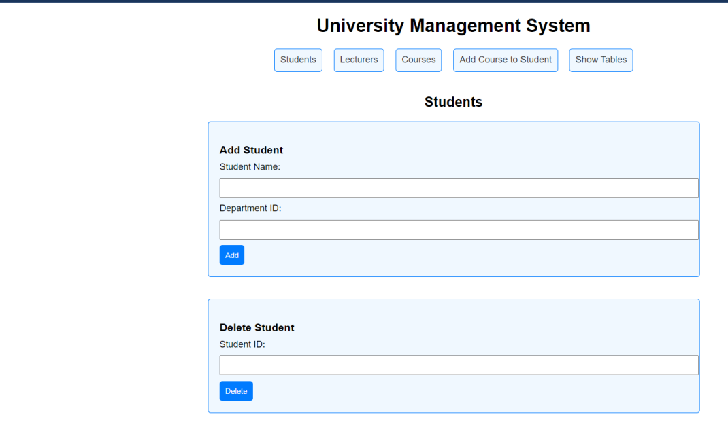
1.3 Edit Student
Used to modify students' data in the system by entering the student's ID. A subsequent page allows the modification of student names.
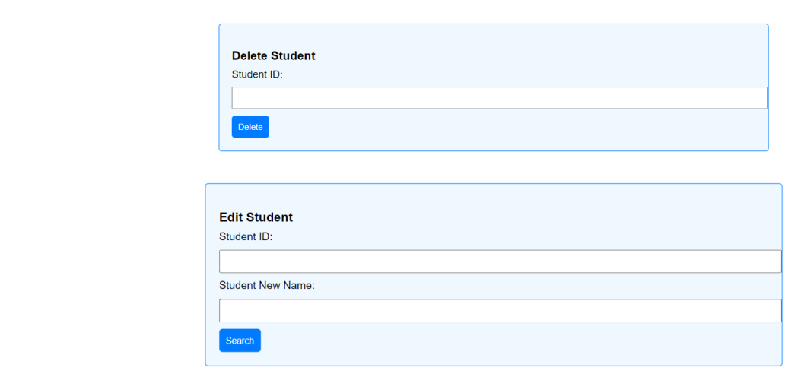
Page 2: Lecturers
2.1 Add Lecturer
This section involves four fields:
Lecturer Name: Input for the lecturer's name.
Lecturer ID: ID given to the lecturer by the employing university.
University ID: Identification for the university the lecturer belongs to.
Speciality: Area of expertise or skill of the lecturer.
2.2 Delete Lecturer
Enables the deletion of a lecturer from the database using the Lecturer ID.
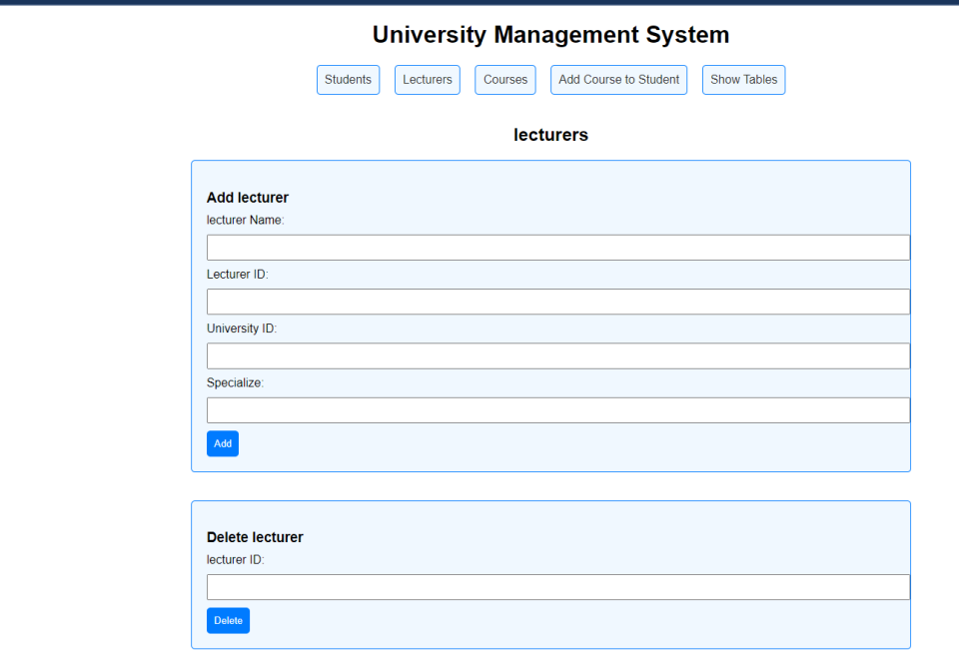

2.3 Edit Lecturer
Similar to the Add Lecturer section, this allows the modification of lecturer information in the database.
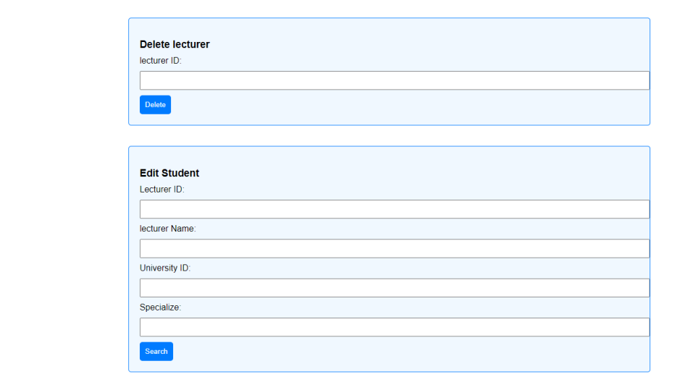
Page 3: Courses
3.1 Add Course
This section is for adding courses to the database. Fields include:
Title: Name of the course.
Start Time: Time when the lecture begins.
End Time: Time when the lecture finishes.
Course Day: Day of the week the course is scheduled.
Lecturer: Lecturer assigned to the course.
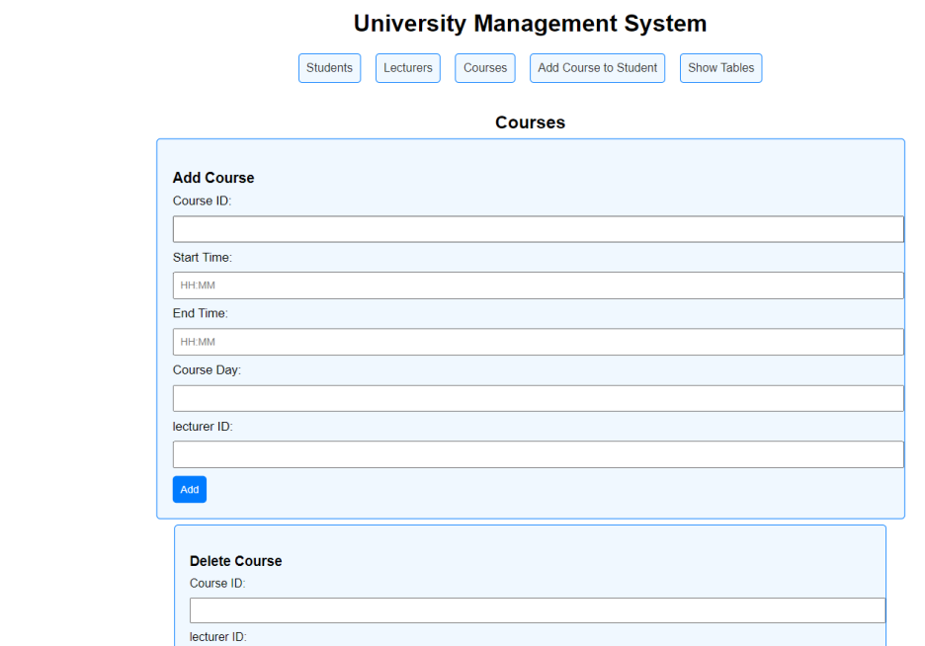
3.2 Delete Course
Used to remove a course that is no longer needed in the database.
3.3 Edit Course
Allows modification of course attributes, including Course ID, Lecturer ID, start time, end time, and course day.
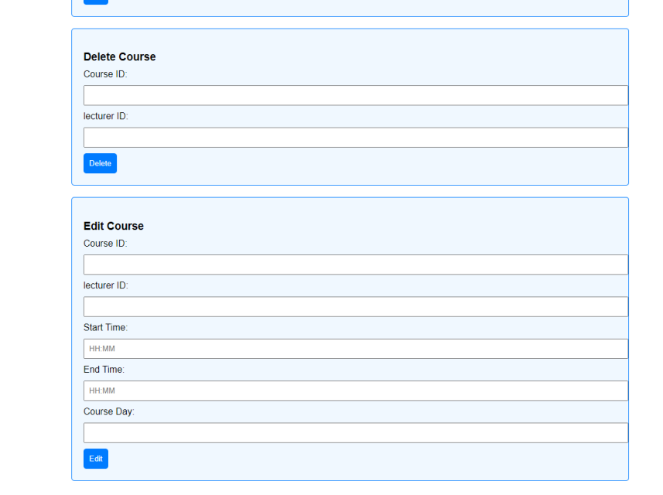
Page 4: Add Course to Student
4.1 Add Course
Enables the addition of a course to a student using the Course ID and Student ID fields. Both IDs must be previously added to the database.
4.2 Delete Course
Used to delete a course that a student no longer wishes to take.
4.3 Set Course Degree
Used after mid-term and final exams to input and communicate the degree a student has achieved in a course.
